INTRODUTION
OVERVIEW
- To create a book coverfor our institution
- Purpose
To reach the students with tha book cover

PROBLEM DEFINITION & DESIGN THINKING
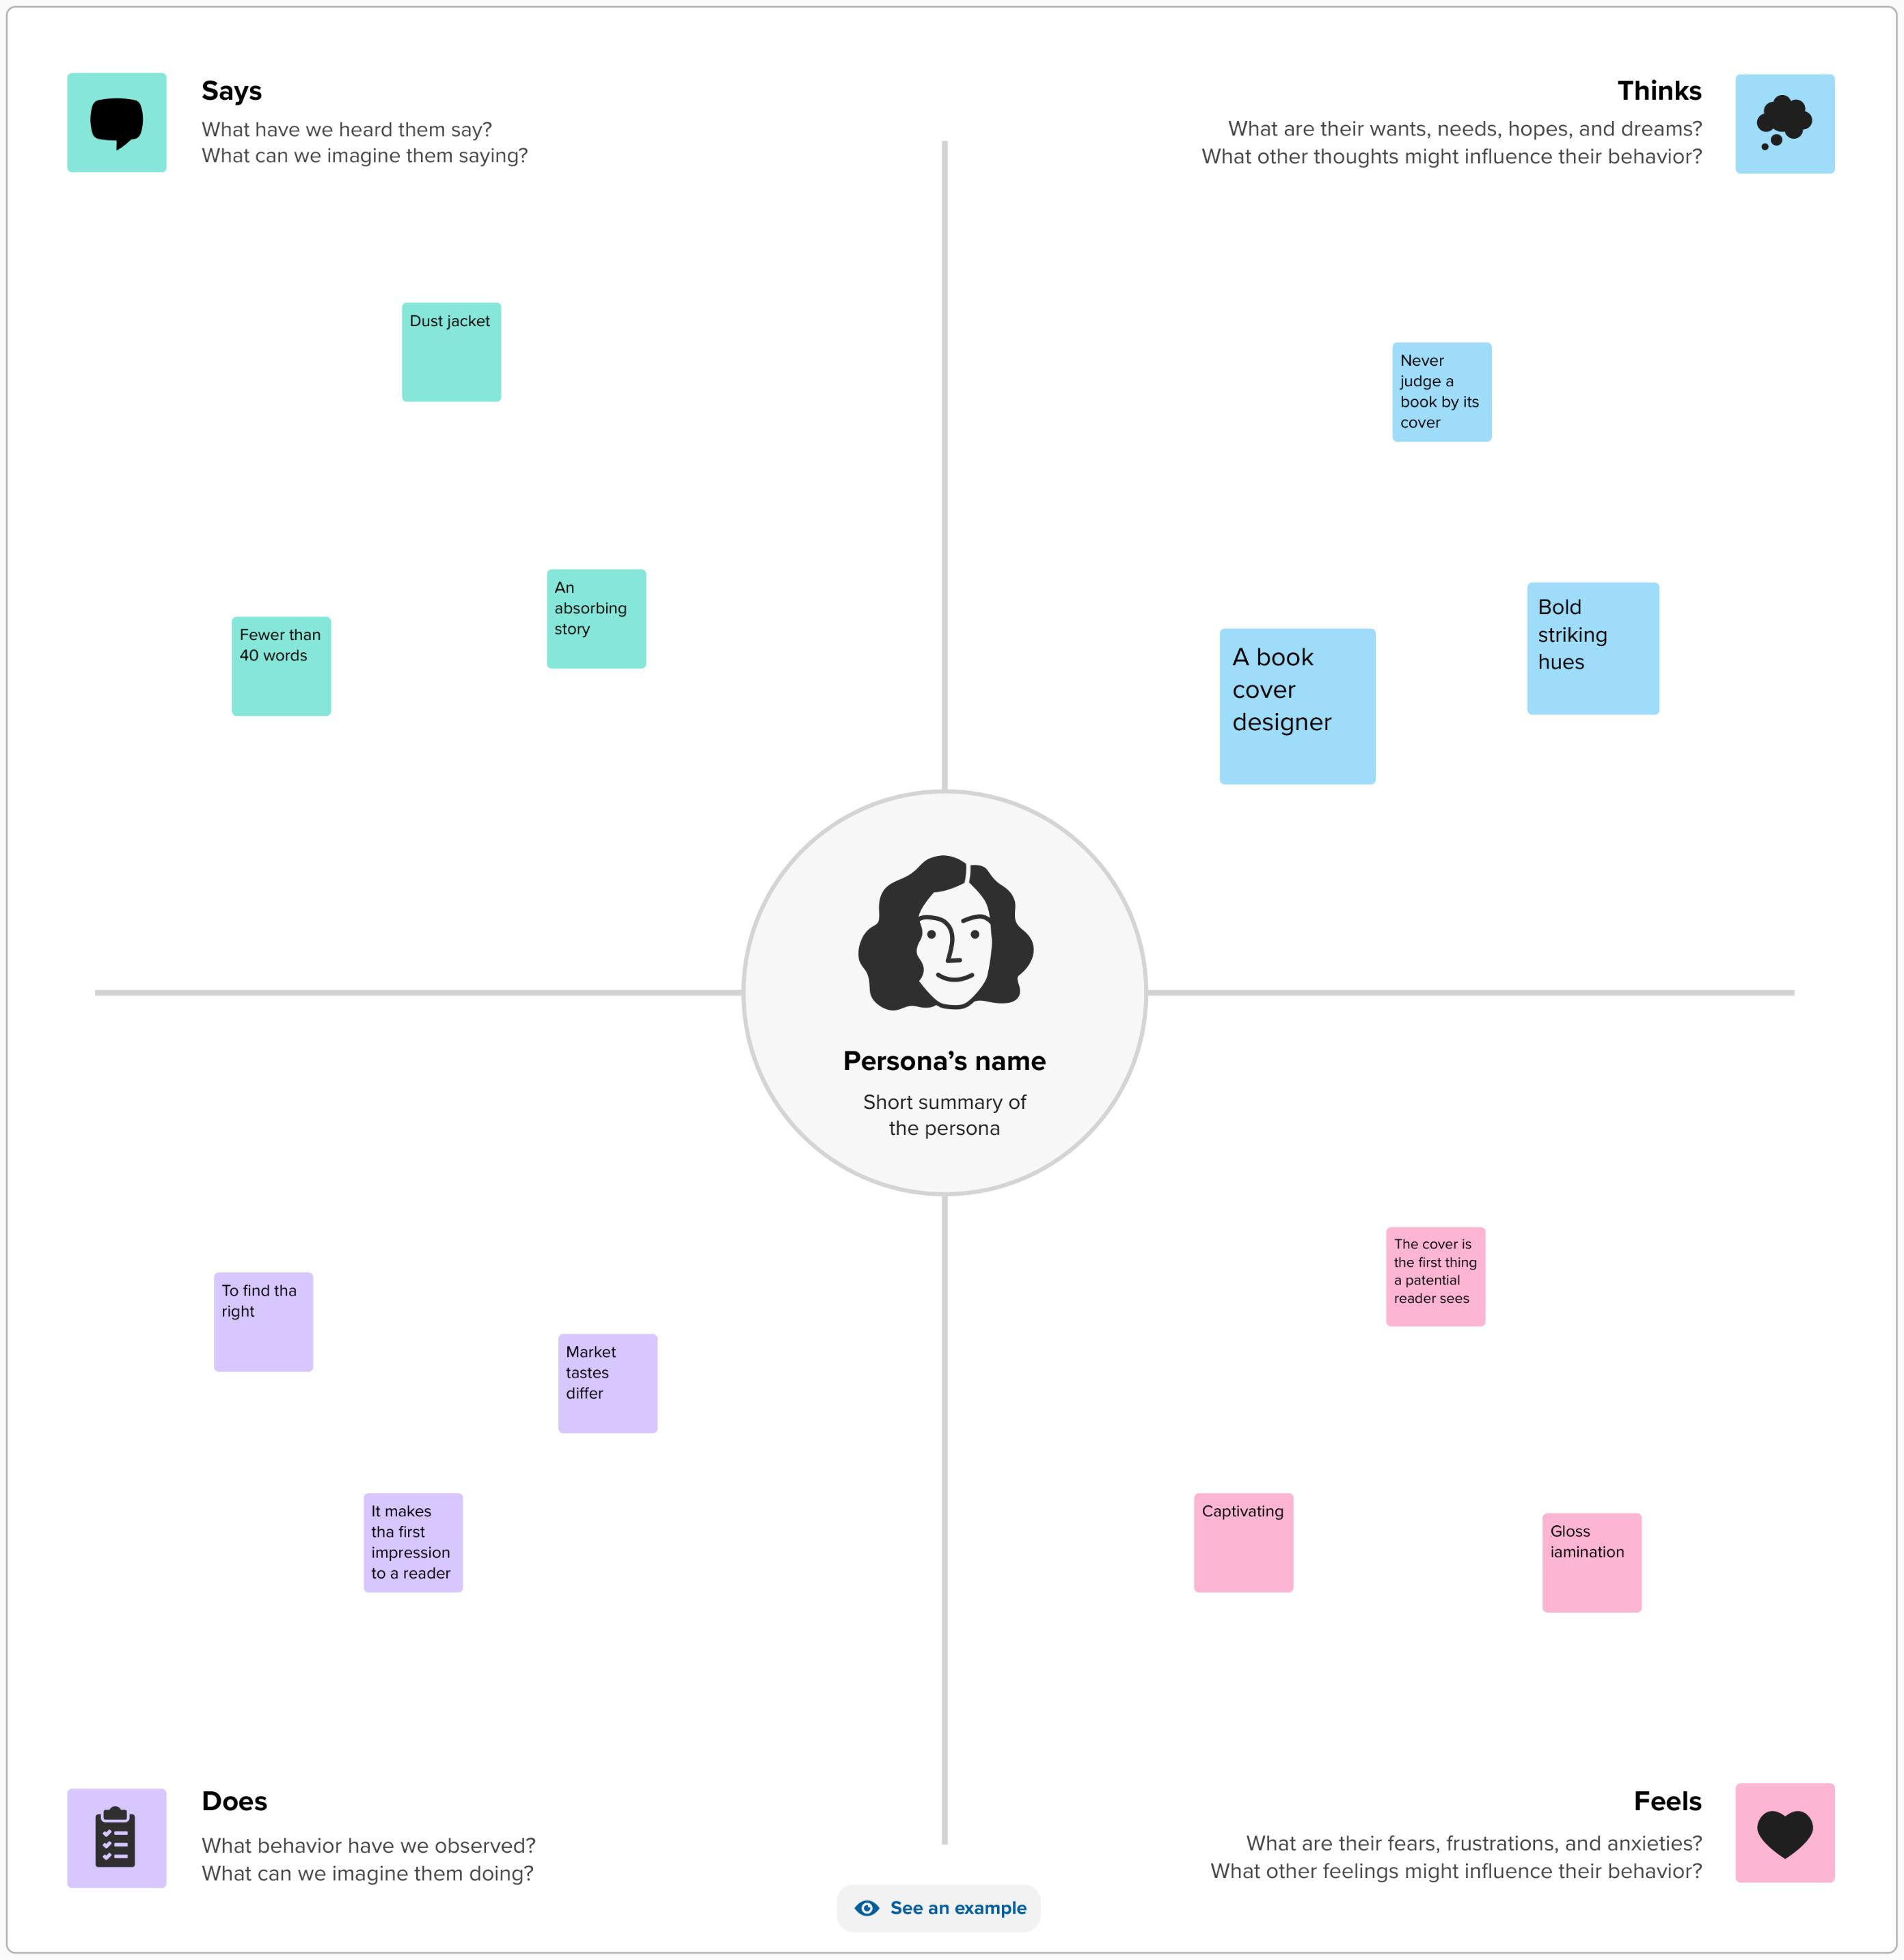
EMPATHY MAP:

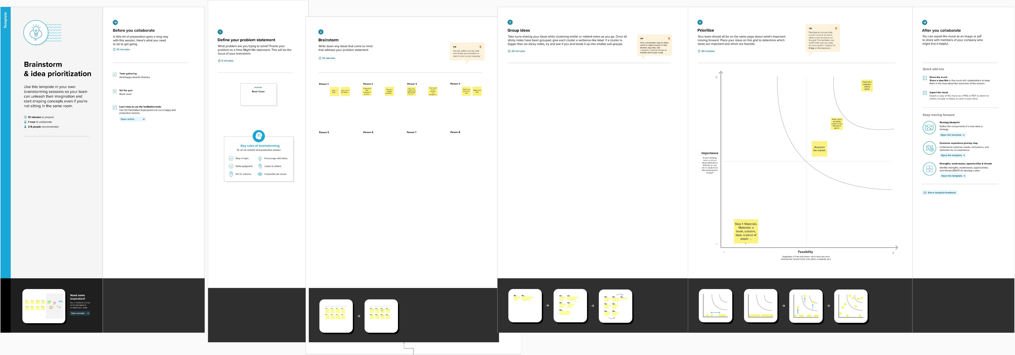
BRAIN STROM :

RESULT


ADVANTAGES & DISADVANTAGE

- It's easy to reach tha people at any time

APPLICATION:
It can gather all people

CONCLUSION:
Successfully created book cover using tha canva app

